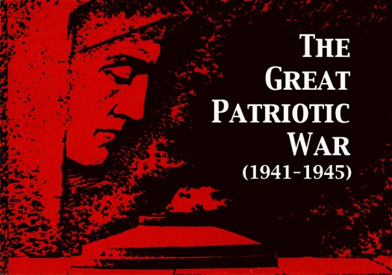 | Задания к Республиканской дистанционной викторине  среди обучающихся профессиональных образовательных организаций Чувашской Республики,  приуроченной к Году памяти и славы и  к 100-летию автономии Чувашской Республики

Уважаемый участник викторины!
Ты можешь проявить творчество - сопроводить ответ иллюстрациями, ответ должен быть полным, но не более 5 предложений.
Помни, что оценивание конкурсных работ осуществляется по следующим критериям:
правильный ответ - 1 балл,
правильный полный ответ - 2 балла,
правильный полный ответ с элементами творчества - 3 балла.

Помни о сроках выполнения и сдачи ответов: 23 - 26 октября 2020 года
Ответы необходимо прислать в электронном виде на адрес lady.uymina@mail.ru с пометкой «Викторина» до 19.00 часов 26 октября 2020 года. В названии файла с ответами укажите свою фамилию, имя, название профессиональной образовательной организации.

В ответах указывается только номер задания, шрифт Times New Roman 11.

образец оформления ответа

Викторина, приуроченная к Году Театра в России

Ф.И.О.____________
название образовательной организации________
курс___
руководитель ____________

I. This day we brought as they could (Этот день мы приближали, как могли)

1.
2.
3.

I. This day we brought as they could (Этот день мы приближали, как могли)

The Nazi invasion of the USSR in June 1941 heralded the beginning of the most titanic battle in the history of humanity. The war ended in complete defeat for Nazi Germany less than four years later with the fall of Berlin on May 9, 1945. Over 20,000,000 Soviet citizens and soldiers died in the struggle to liberate the Motherland from the fascist aggressors.

1. When did the Great Patriotic War begin?

2. Which countries in the Allies took part in World War II?

3. Which was the first major battle of the Soviet Army? Why?

4. Who were the Night Witches called?

5. How long was the siege of Leningrad?

6. How many days did the battle of Stalingrad last?

7. Who was nicknamed the White Rose of Stalingrad? For what deeds was this person awarded a Gold Star of a Hero of the Soviet Union?

8. On which day did the Flag of Victory flutter on the Reichstag building? What meaning did it have?

9. Who was the most important Soviet military leader of World War II who is considered to be instrumental at four key points of Soviet resistance?

10. How much did the Soviet Union lose in World War II? (I mean: Loss of life and damage in the Soviet Union in the Great Patriotic War)

11. What Hero Cities do you know?

12. How many Chuvash people received the Hero of the Soviet Union title during the Great Patriotic War?

13. When was the first ever Victory Day celebrated in our country?

14. Why do Victory Day parades traditionally start at 10 a.m. local time?

15. Why is Victory Day celebrated on May 9th in Russia when in Western Europe it’s May 8th?

II. The country of one hundred thousand words, one hundred thousand songs and one hundred thousand embroideries (Край 100 тысяч слов, 100 тысяч песен)

1. In which century did the word ‘Chuvash’ appear?

2. When was the Chuvash Independent Republic born? How many times was it renamed?

3. What are the national symbols of the Chuvash Republic?

4. How many administrative districts are there in the Chuvash Republic?

5. How many ethnographic groups are the Chuvash divided into? Which ones? What are the main differences between them?

6. Which medals was the Chuvash Republic awarded? For what?

7. When was the Day of the Republic celebrated for the first time? What event was its celebration linked with?

8. What is Nadezhda Pavlova famous for? How is her name linked with Cheboksary?

9. Whose name is the best symbol of the renewal and soaring growth of Chuvashia in the Soviet years? In the article “From the Wooden Plough to the Stars” this person writes about countrymen who have instilled in respect for work and the working.

10. “Do you know a people
In whose land a thousand songs are sung.
And a thousand colours shine
On Embroideries? ”
Whose words are these? Why does the author describe our Republic in such a poetic way?

III. Tastes differ (Все работы хороши, выбирай себе на вкус)

1. When is the Day of Professional Technical Education celebrated in the Russian Federation?

2. What was the name of the first trade school in Russia? Where was it located? Who contributed to it?

3. What is the difference between a vocational school and a technical school?

4. Who were the world-known graduates of Soviet vocational schools (their names are famous in different spheres of life all over the world)?

5. What educational establishments in the Chuvash republic are the oldest?

